|  |
| --- |
| GAP Claims Power Automate Solution  Deployment Guide |

Contents

1. Document information 3

2. Purpose 4

3. Solution Deployment Guide 4

3.1 Power Automate Flows 4

3.1.1 Convert Mail 4

3.1.2 P Delete Deleted Documents 5

3.1.3 P Mark Older than 30 days as Delete 5

3.2 Export Solution from Environment 5

3.3 Import Solution to Environment 9

# Document information

**History**

|  |  |  |  |
| --- | --- | --- | --- |
| **Date** | **Version** | **Revision Author(s)** | **Notes** |
| 10/08/2022 | 1.0 | Komal Singh |  |
|  |  |  |  |
|  |  |  |  |
|  |  |  |  |
|  |  |  |  |

**Reviewers and Approvers**

|  |  |  |  |
| --- | --- | --- | --- |
| **Date** | **Version** | **Reviewer/Approver (role)** | **Note** *(State if document was reviewed or approved. Add additional notes, and* ***Screenshot of Approval Email****)* |
|  | 1.0 |  |  |
|  |  |  |  |
|  |  |  |  |
|  |  |  |  |
|  |  |  |  |

# Purpose

The purpose of the Deployment Guide document is to provide the procedures which need to be followed for exporting and Importing of Power Automate solution to the environment.

# Solution Deployment Guide

## Power Automate Flows

### Convert Mail

**Description –** Runs an Event when a mail is composed to following mailbox address

(dev.usz.gapclaims@zurichna.com,qa.usz.gapclaims@zurichna.com)

**Configuration-** This flow triggers based on an Event(When a new mail arrives)

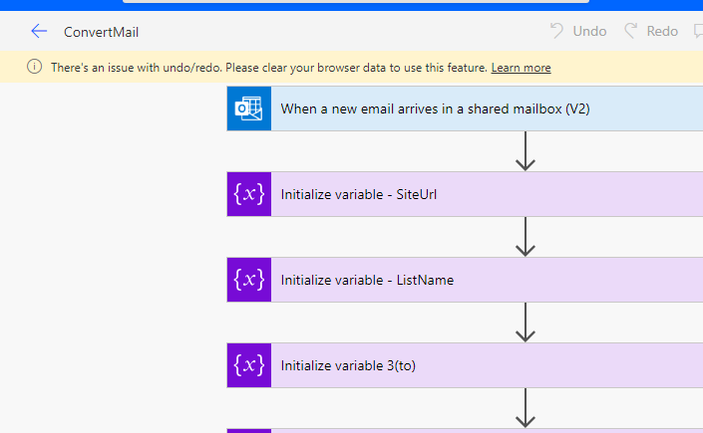

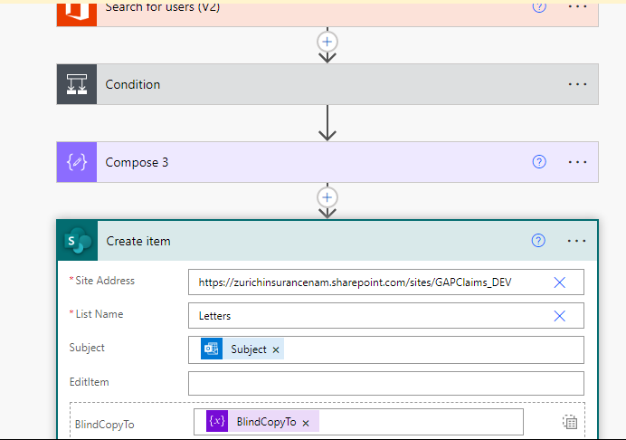

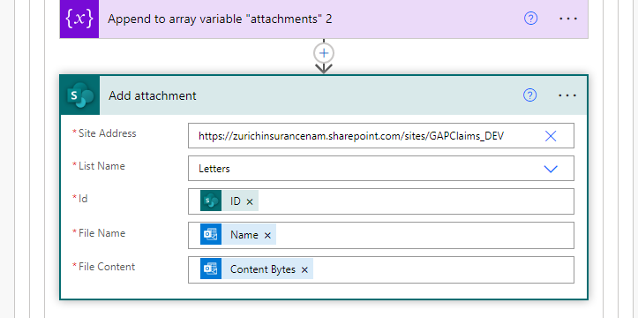

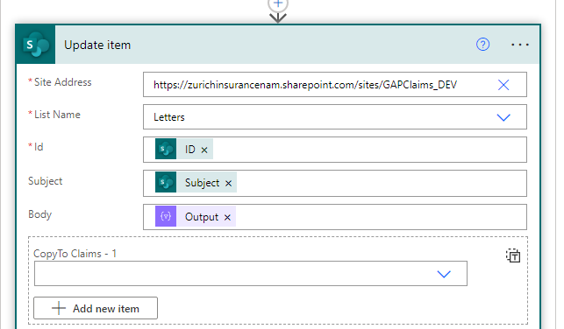

Above snap refers where to change the configuration of the URL:

**Product Site URL** - “[https://zurichinsurancenam.sharepoint.com/sites/GAPClaims](https://zurichinsurancenam.sharepoint.com/sites/GAPClaims%20) “

**QA Site URL** - “<https://zurichinsurancenam.sharepoint.com/sites/GAPClaims_QA>“

**Dev Site URL** - “[https://zurichinsurancenam.sharepoint.com/sites/GAPClaims_DEV“](https://zurichinsurancenam.sharepoint.com/sites/GAPClaims_DEV)

### P Delete Deleted Documents

**Description –** This flow is to delete the documents where the document Status is Delete.

**Configuration –** This is a Scheduled flow and runs on weekly basis (every Sunday at 10:30 PM).

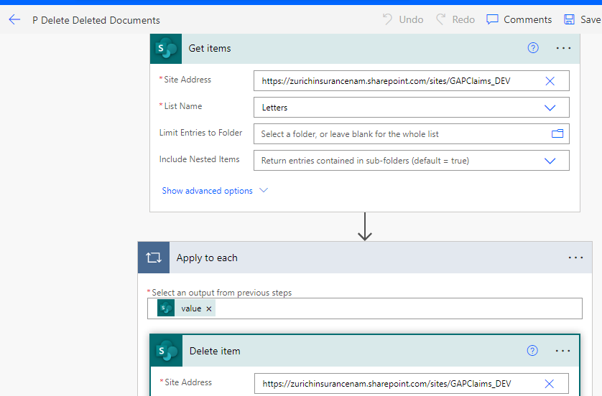

Above snap refers where to change the configuration of the URL:

**Product Site URL** - “[https://zurichinsurancenam.sharepoint.com/sites/GAPClaims](https://zurichinsurancenam.sharepoint.com/sites/GAPClaims%20) “

**QA Site URL** - “<https://zurichinsurancenam.sharepoint.com/sites/GAPClaims_QA>“

**Dev Site URL** - “[https://zurichinsurancenam.sharepoint.com/sites/GAPClaims_DEV“](https://zurichinsurancenam.sharepoint.com/sites/GAPClaims_DEV)

### P Mark Older than 30 days as Delete

**Description –** This flow is to mark the documents which are older than 30 days.

**Configuration –** This is a Scheduled flow and runs daily at 10:30 PM.

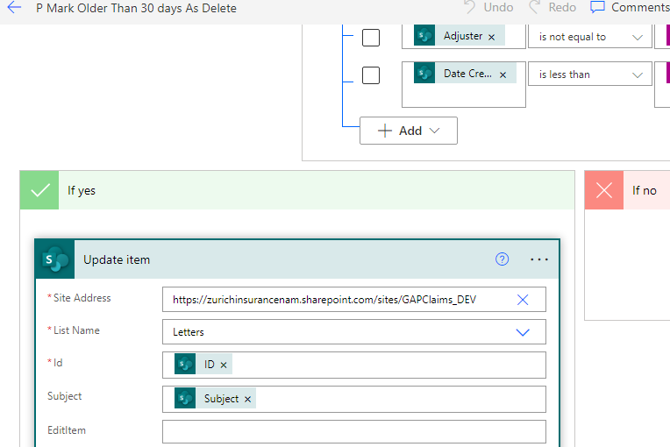

Above snap refers where to change the configuration of the URL:

**Product Site URL** - “[https://zurichinsurancenam.sharepoint.com/sites/GAPClaims](https://zurichinsurancenam.sharepoint.com/sites/GAPClaims%20) “

**QA Site URL** - “<https://zurichinsurancenam.sharepoint.com/sites/GAPClaims_QA>“

**Dev Site URL** - “[https://zurichinsurancenam.sharepoint.com/sites/GAPClaims_DEV“](https://zurichinsurancenam.sharepoint.com/sites/GAPClaims_DEV)

## Export Solution from Environment

**Step 1**: Log on to <https://www.office.com> Office365 Portal using “[**svc-PowerAutomate-53@zurich.com**](mailto:svc-PowerAutomate-53@zurich.com)” and Click App launcher on top left corner of the page and select Power Automate app from the option.

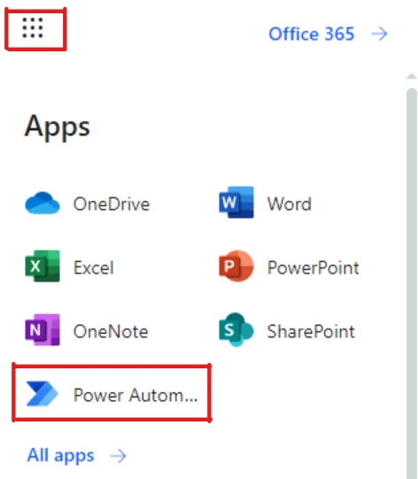

**Step 2**: Click the Environment option on top menu and change it from “Personal Productivity” to “POPL-US-001036-DEV” environment.

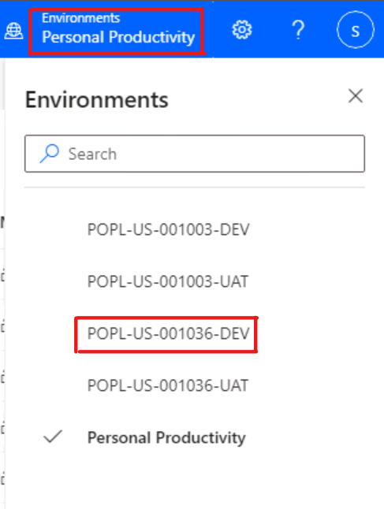

**Step 3**: Select the Solution link from the left navigation inside the power automate app and make sure that the flows are OFF.

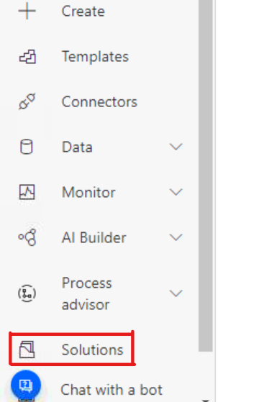

**Step 4**: Select the solution which need to be exported and click the export option on top.

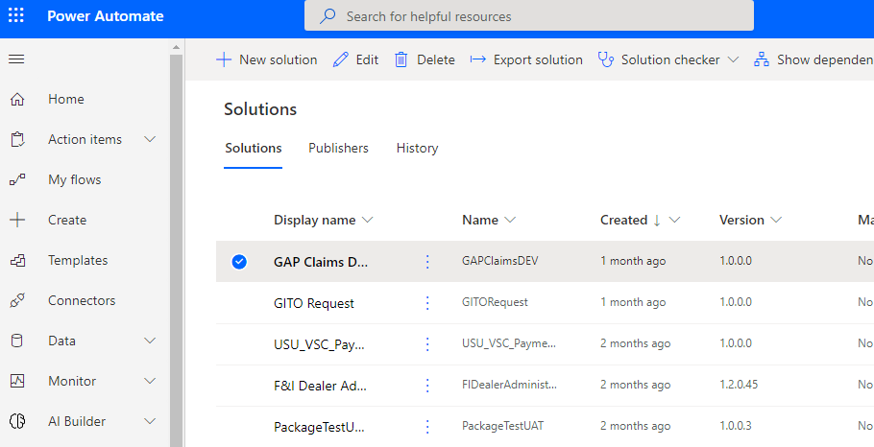

**Step 5**: Make sure that there are not issues shows under “check for issues” after Publishing and Running then Click Next button from the right pane window to export the solution.

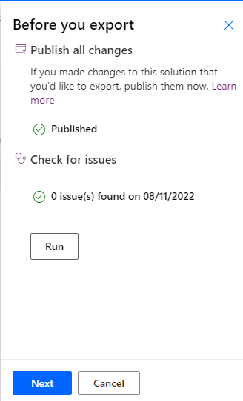

**Step 6**: Default Select of export as Managed and click export button to export as Zip File.

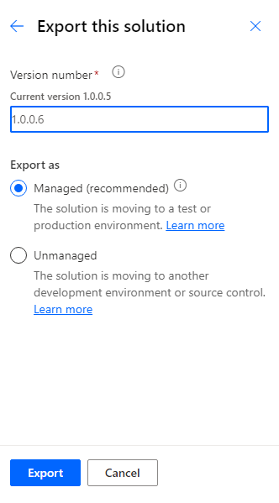

**Step 7**: After click export button, below captured message will be shown while the solution starts to export.

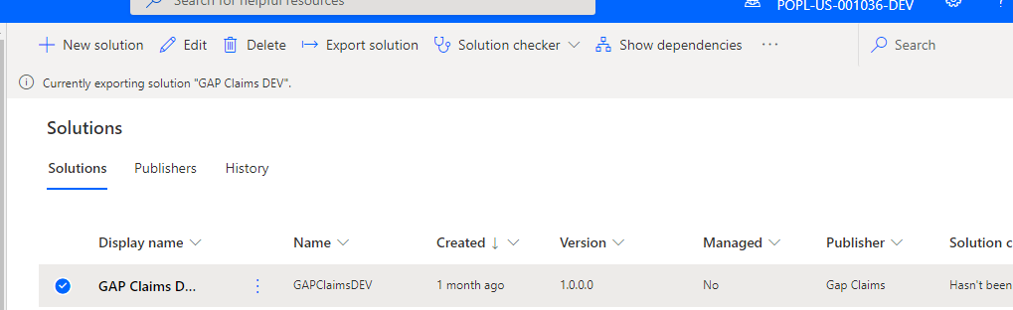

**Step 8**: Solution exports successful message will be shown and can click on download option then export file will be downloaded to the downloads folder shown below.

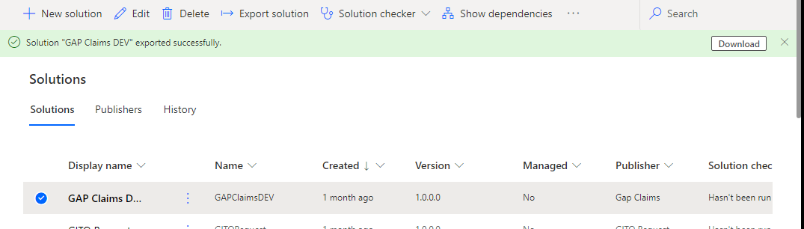

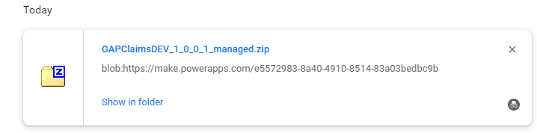

## Import Solution to Environment

**Step 9**: Click the Environment option on top menu and change from “POPL-US-001036-DEV” it to “POPL-US-001036-PROD” Production Environment.

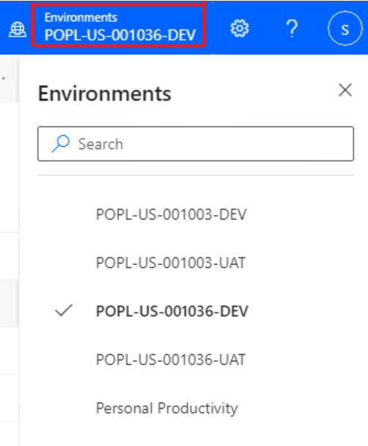

**Step 10**: Click the import option on top of the page to upload the exported solution to new environment.

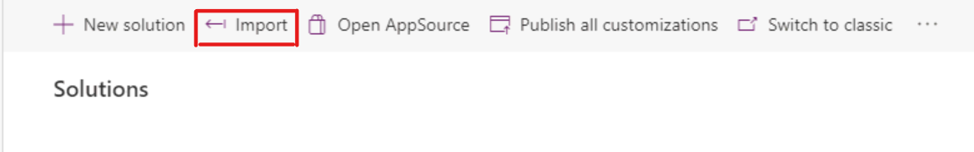

**Step 11**: Click browse option and select the downloaded solution Zip file from the local.

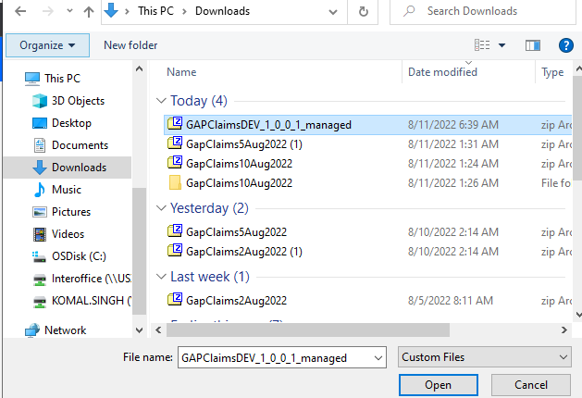

**Step 12**: Click Next button after select the Zip file from right pane window.

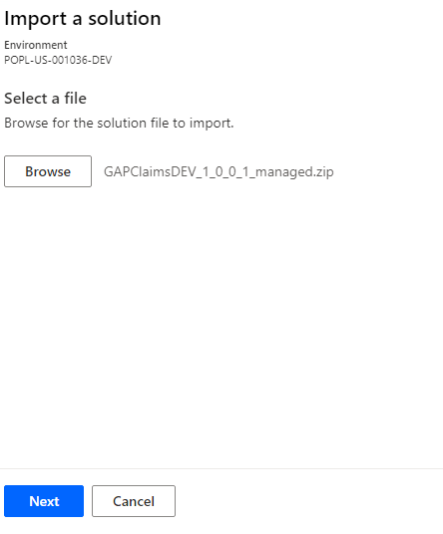

**Step 13**: Imported solution app name and version will be displayed. Confirm and click next button.

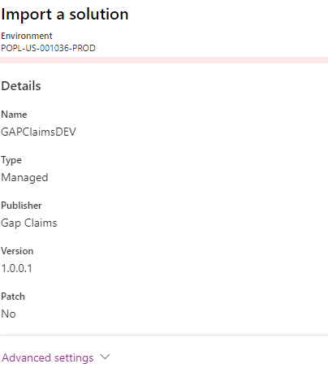

**Step 14**: The SharePoint and Outlook connection used in the flow will be listed down. Selects [svc-PowerAutomate-53@Zurich.com](mailto:svc-PowerAutomate-53@Zurich.com) service account to from the dropdown if it is not selected default while import.

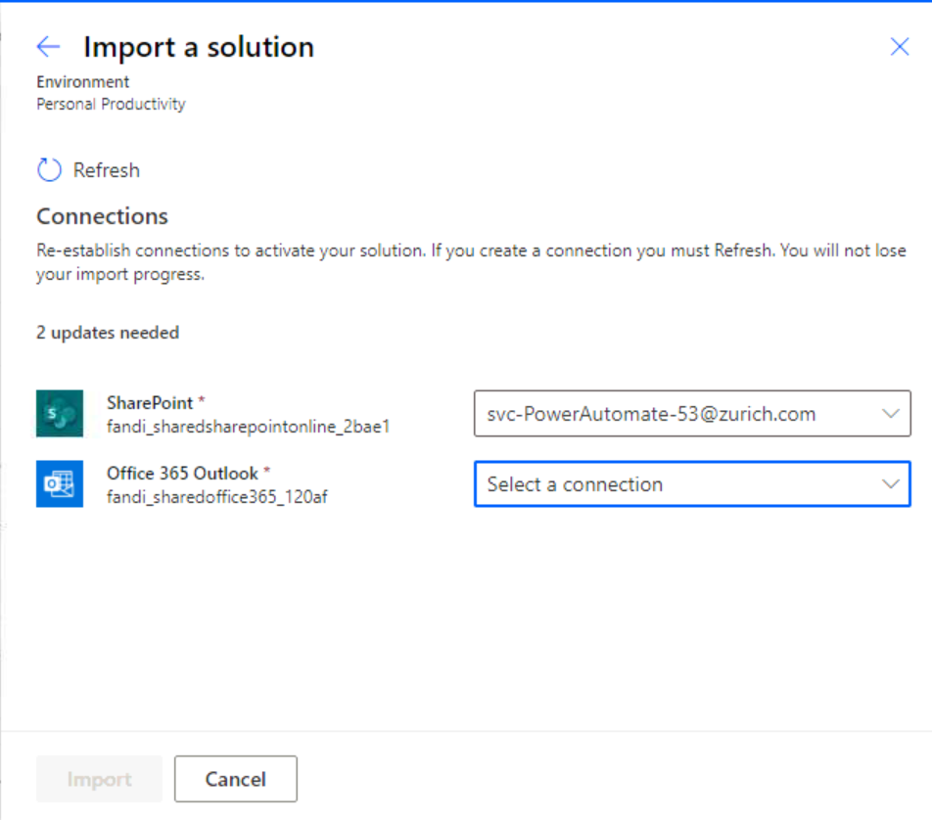 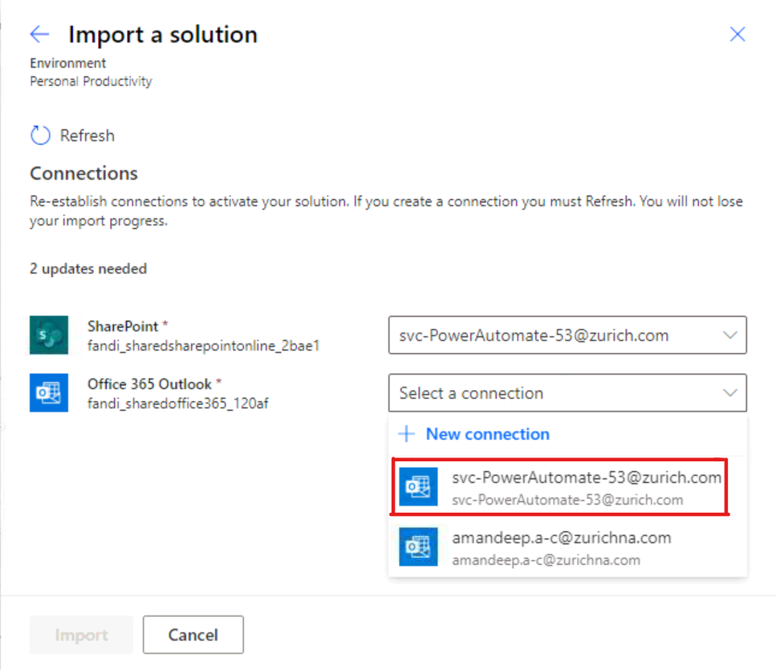

**Step 15**: Click Import button after selects the service account for all the connection which needs be established.

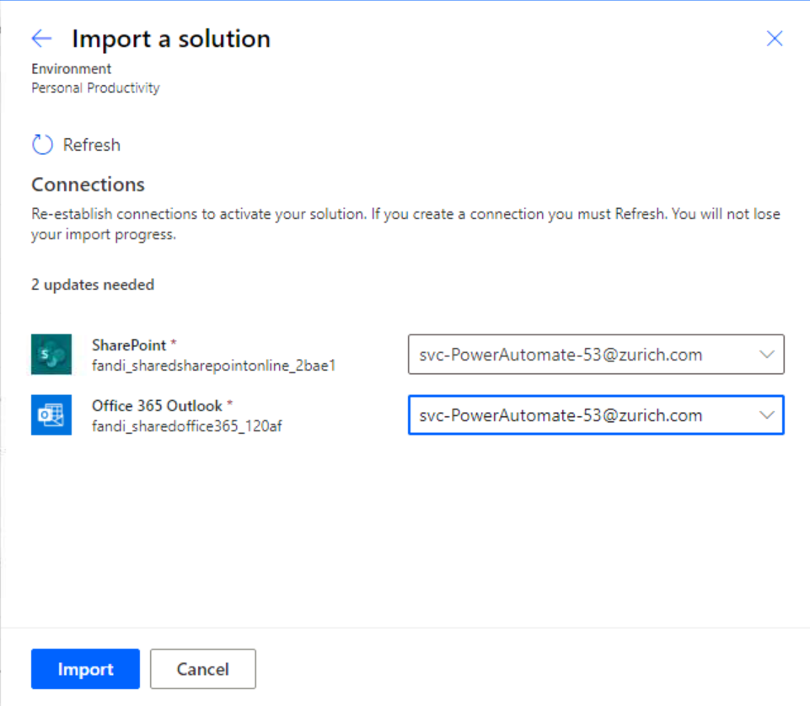

**Step 16**: Make sure that imported solution is showing under the solutions.



**Step 17**: Click the solution display name and make sure that below three flows are present under the solution. 